# **User Documentation for** **“Frizza App Review Analysis Dashboard” and “Back Validation Tool”**

It is hard to read thousands of user reviews from Play Store to get a strong understanding of user pain points accurately. And it is even harder to see change in user pain points with respect to time. To solve this problem “Frizza App Review Analysis Dashboard” and “Back Validation Tool” can be used. Both the tools are built to work together and complement each other in understanding user pain points effectively.

* **Purpose of “Frizza App Review Analysis Dashboard” and “Back Validation Tool”**

**For “Frizza App Review Analysis Dashboard”:** The purpose of the “Frizza App Review Analysis Dashboard” are:

1. To give an overview of user sentiment for a particular review rating, app version and span of time.
2. To give a time series information of changing user sentiment over a period of time for particular rating and app version.
3. To get a brief description of what terms and topics are trending for a particular sentiment for a particular rating and app version in a defined instant of time.

**For “Back Validation Tool”:** The purpose of “Back Validation Tool” are:

1. To give detailed description of a defined section of users by different metrics like rating, app version and span of time.
2. To find a particular section of user review independent of “Frizza App Review Analysis Dashboard”.

* **Purpose of this Documentation**

This documentation aims to provide a detailed information about how to use “Frizza App Review Analysis Dashboard” and “Back Validation Tool” to get user review sentiment information. This documentation is a User Documentation and not a Developer Documentation. This documentation does not aim to provide information about how to build and manipulate any tools. There is a separate Developer Documentation for such use cases.

## **Frizza App Review Analysis Dashboard**

The Frizza App Review Analysis Dashboard is a Tableau Dashboard hosted on Tableau Public profile. This dashboard can be opened as a web tool in any popular web browser. This section would start with first describing each and every component of the Dashboard that is being shown in Figure 1. After describing all the components use cases would be described.

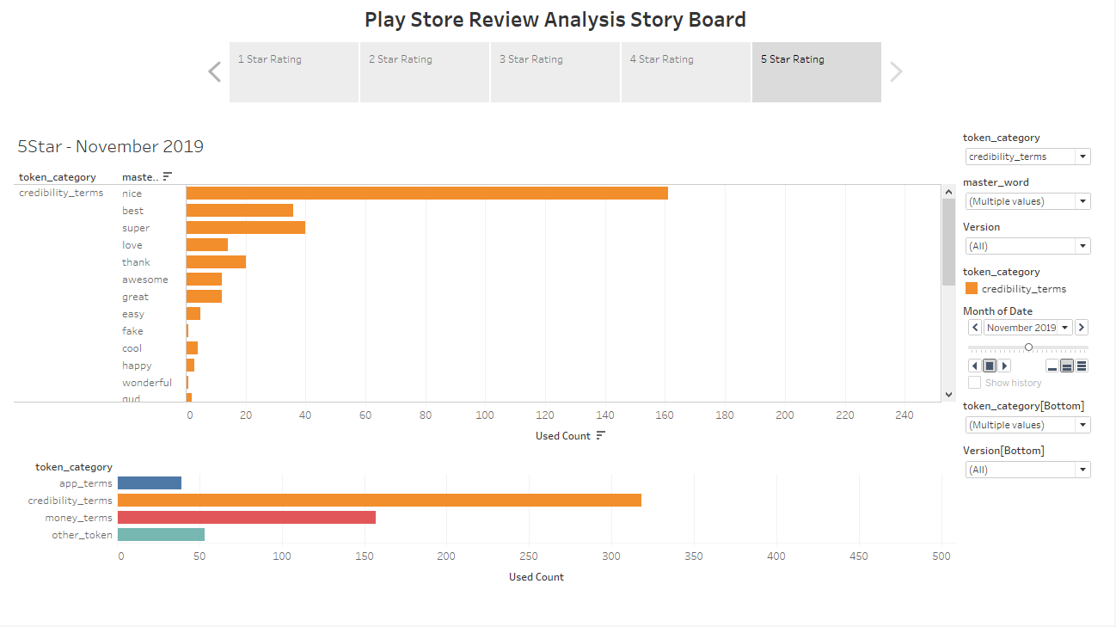

Figure 1: Dashboard Overview

* **Description of Dashboard Components**

1. **Rating Change Section:** This is the top most section just below the heading of the Dashboard. The tool is made in the form of a *rating-based story board*. And this section allows the user to select different rating (1 to 5 star). Only one rating section can be viewed at a time in this dashboard. To compare and view multiple rating section please open this dashboard in multiple browser tabs. Rating 5 and Rating 1 selection are shown in Figure 2 and Figure 3 respectively.

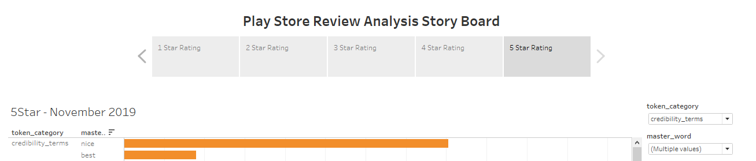

Figure 2: Rating 5 selected in Dashboard

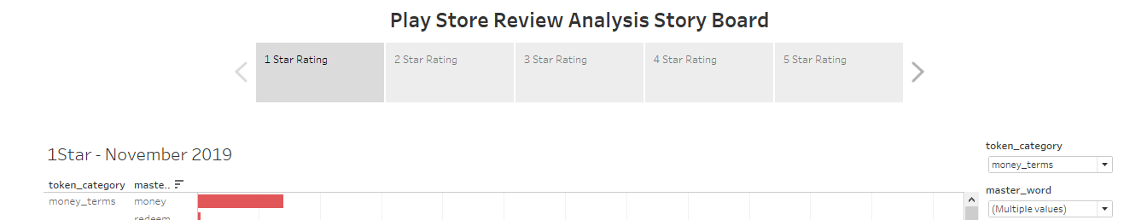

Figure 3: Rating 1 selected in Dashboard

1. **Overall Sentiment Chart:** This is the bottom most chart with four bars representing strength of different sentiments during a span of one month. The figure of the section is shown below in Figure 4.

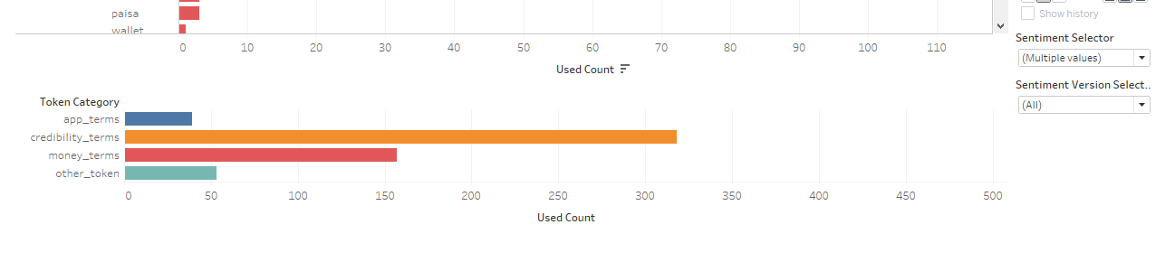

Figure 4: Overall Sentiment Section at the bottom of dashboard

These bars can be altered with respect to different app versions and Sentiment Category. This chart can be altered with respect to “App Version” by **Sentiment Version Selector** dropdown in the bottom right corner of the dashboard. The image of Sentiment Version Selector is shown in Figure 5 and Figure 6.

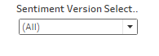

Figure 5: Sentiment Version Selector

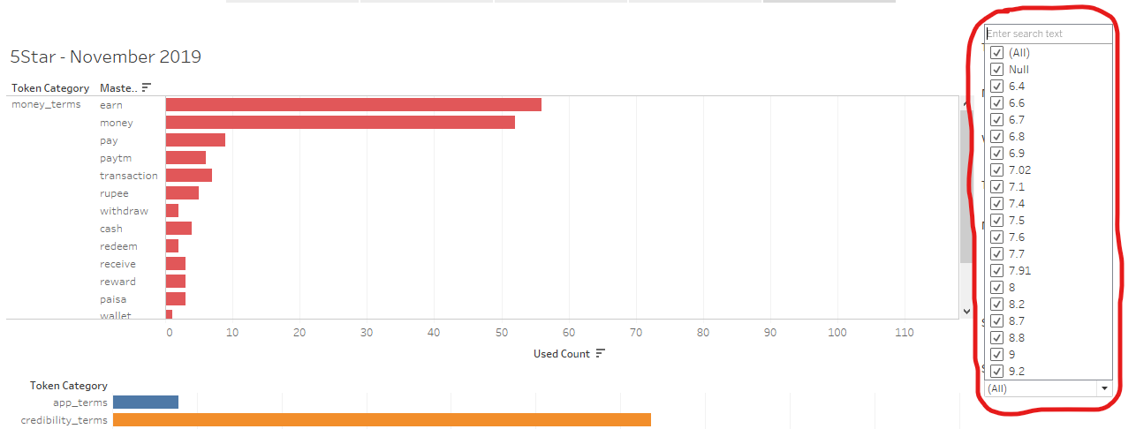

Figure 6: Extended View of Sentiment Version Selector

The Overall Sentiment Chart at the bottom of dashboard can also be altered wit respect to sentiment shown in the chart. The **Sentiment Selector** Dropdown list above Sentiment Version Selector Dropdown tab is responsible for changing shown sentiments in the chart. *In future more sentiments classes can be added or removed from Sentiment Selector dropdown list and Overall Sentiment Chart with respect to different apps for which this tool would be deployed.* The Figure 7, 8 and 9 shows Sentiment **Selector** Dropdown and how its altered.

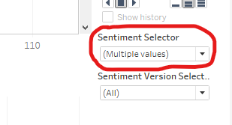

Figure 7: Sentiment Selector Dropdown

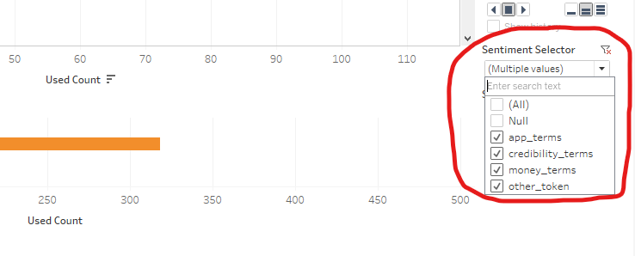

Figure 8: Expanded Sentiment Selector Dropdown.

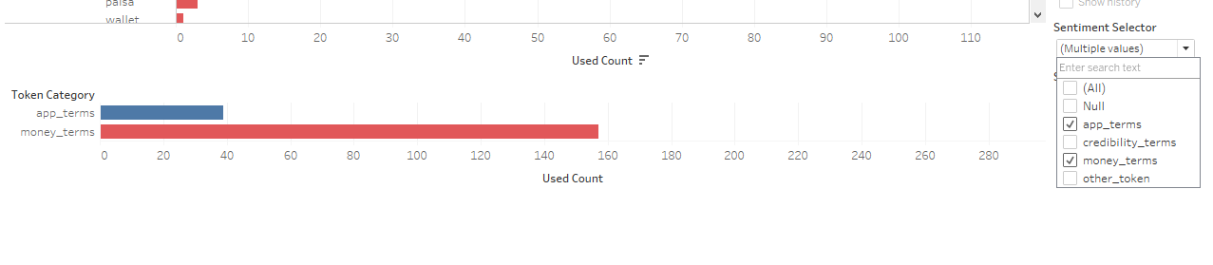

Figure 9: Only "app_terms" and "money_terms" Sentiment are shown as they are the only selected Sentiment category in Sentiment Selector Dropdown list

***\*\*\*NOTE:*** **“Null”** in **Sentiment Version Selector Dropdown** refers sentiment from those reviews which were given after uninstalling the app on Play Store.

1. **Token/Word Chart:** Token Chart shows different keyword associated with each sentiment in Overall Sentiment Chart. This chart shows count of each token used during a span of a month for different app versions, overall user sentiment, ratings and master word. (**Master word** is a word assigned to similar words in user reviews. e.g. ***rupee*** *is the master word different words used by user like rupee, rs, rupay, etc.*). The token chart also shows Rating, Month and Year tag at its top left corner and this applies for Overall Sentiment Chart also. Figure 10 shows token chart inside the dashboard.

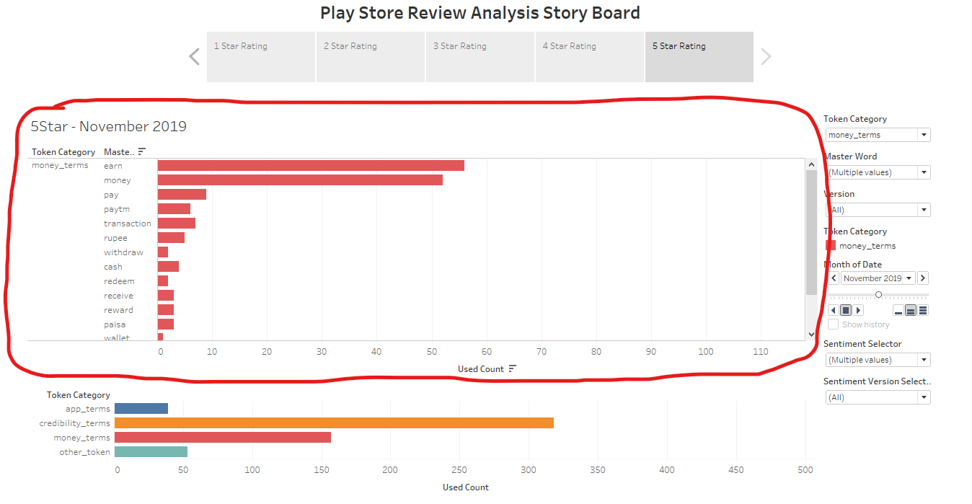

Figure 10: Token Chart in Dashboard

This chart can be altered wit respect to Token Category (Overall Sentiment Category), Master Words, App Version by **Token Category** Dropdown list, **Master Word** Dropdown list and **Version** Dropdown list respectively. The location of these three dropdowns in chart is shown in figure 11. They can be altered in a similar manner as described for Overall Sentiment Chart dropdowns.

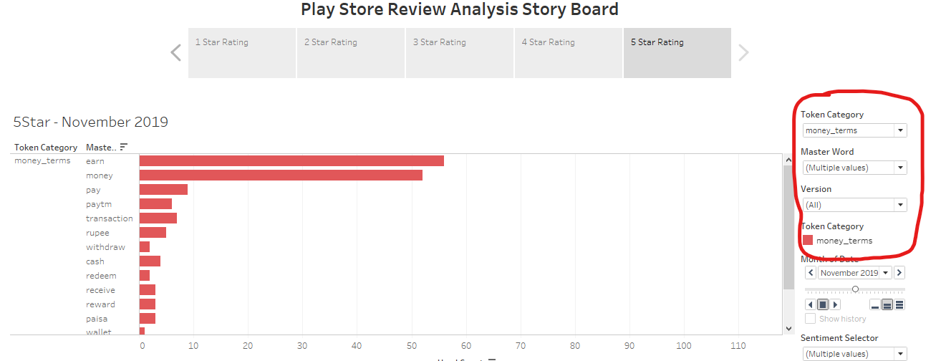

Figure 11: **Token Category**, **Master Word** and **Version** dropdown list in Dashboard.

1. **Time Slider:** The time slider is located in mid right corner of the dashboard between Token Category Colour Representer and Sentiment Selector dropdown. The change in date can immediately be seen in Rating, Month, Year heading above Token Chart. The location of time slider and heading is shown in Figure 12.

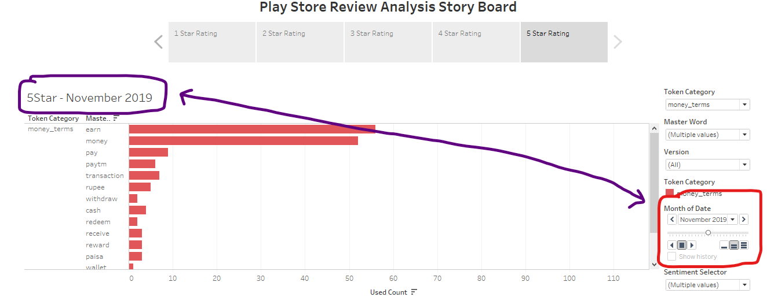

Figure 12: Time Slider and Time Heading in the dashboard

## **Back Validation Tool**

Back Validation tool is a cloud Jupyter Notebook hosted on Google Colab. It is designed to sort and download Play Store user reviews with respect to different conditions like time, app version, Ratings and Master Word. The Back Validation Tool accepts these information with the help of an inbuilt user form. The tool also demands file name (without any extensions like .csv, .xlsx, etc.) to generate csv file of sorted user reviews. The Back Validation Tool stays in Google Drive and is an easy to use web tool. The front view of the Back Validation tool is shown in Figure 13.

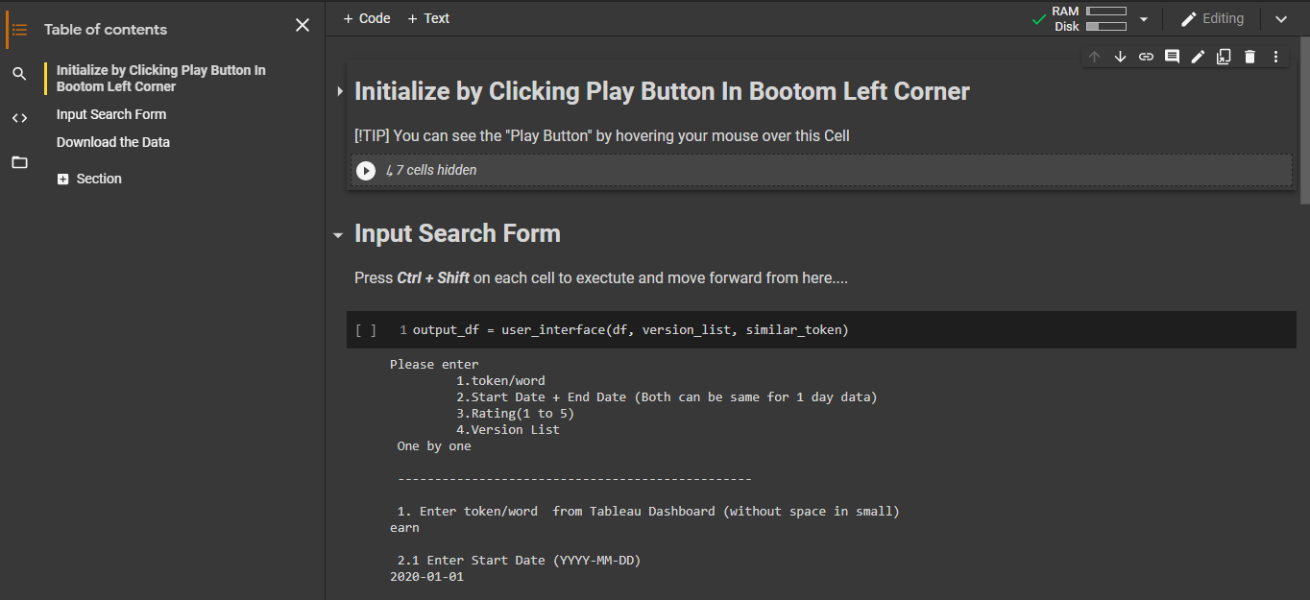

Figure 13: Back Validation Tool

To use Back Validation tool after opening its front page, follow these steps.

1. Click on the white arrow shown in Figure 14. This would initialize Jupyter Notebook and would allocate RAM and Memory resources to run the notebook. The status of RAM and Memory allocated can be seen on the top right corner with a check sign in figure 13.

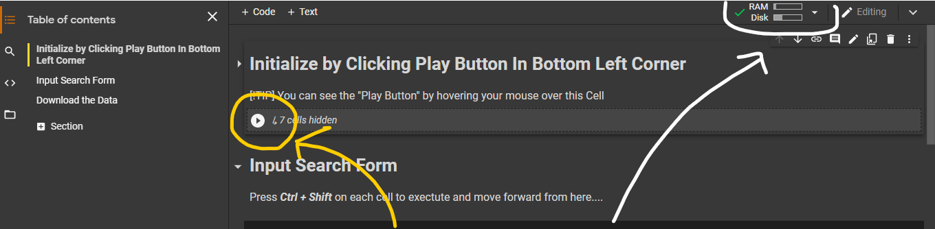

Figure 14: Initialization button and RAM + Memory Status

1. Press Play button by hovering your cursor over bracket in next section as shown in figure 15 and 16. This would initiate a user form that user has to fill to get the sorted user review list and csv file.

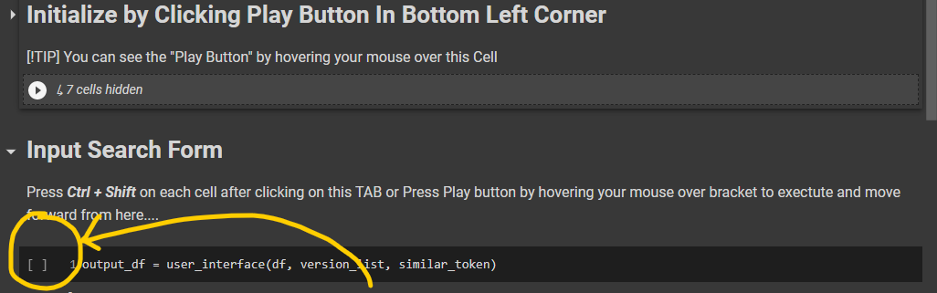

Figure 15: Bracket to hover your mouse over.

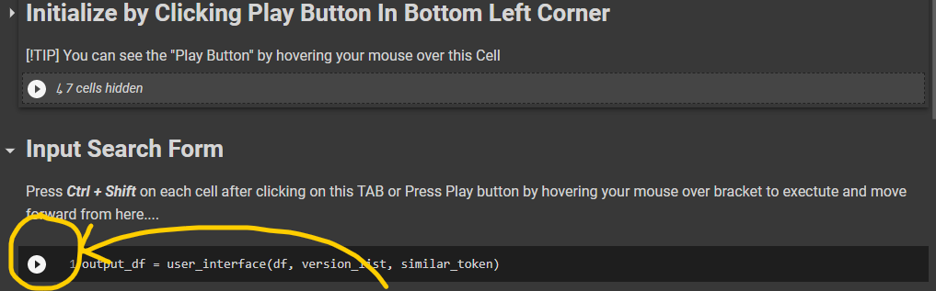

Figure 16: Play Button to press to initiate the form.

1. Play button would initiate a user form that has to be filled step by step. And if the input format is wrong the form execution would stop and then user has to initiate the form again. The filled form is shown in figure 17 and 18.

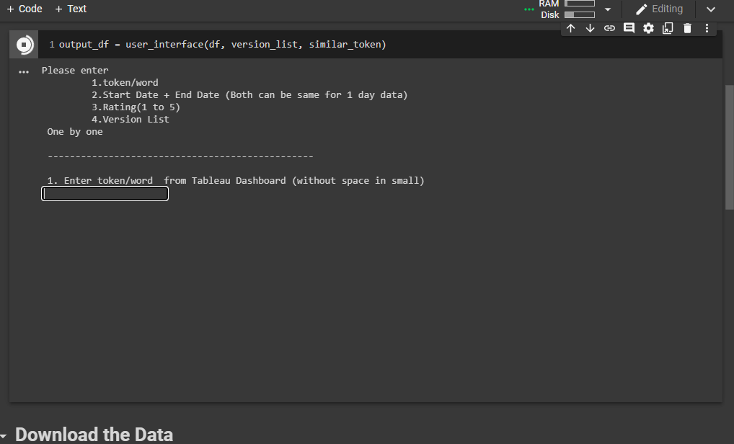

Figure 17: User Form

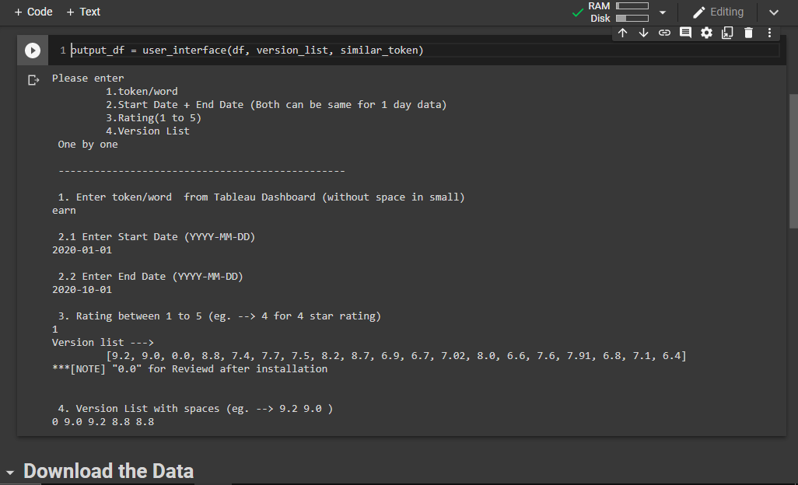

Figure 18: A completely filled form

1. After filling the form press on play button below “Download the Data” tab to enter name of the file to download and view the csv file. This is shown in figure 19.

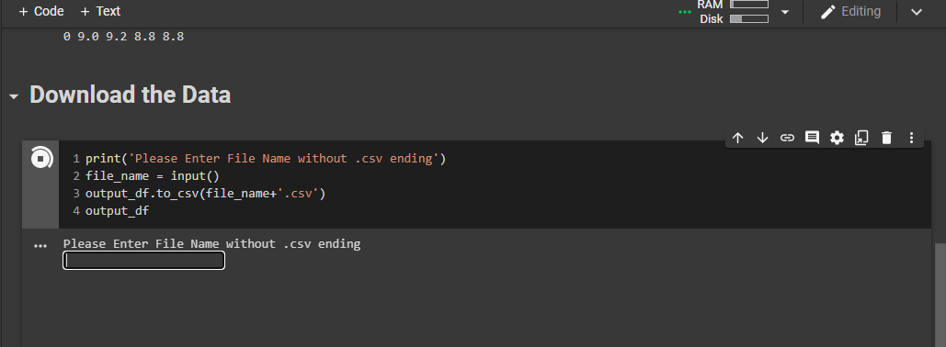

Figure 19: Form to fill user name

After completing these steps an overview of csv file is shown below user from. And file can be downloaded by opening folder section in left side of the notebook. This is shown in figure 20 and 21. The file could only be downloaded in **.csv** format. The file would have the same name as given by the user in filename form as shown in step 4.

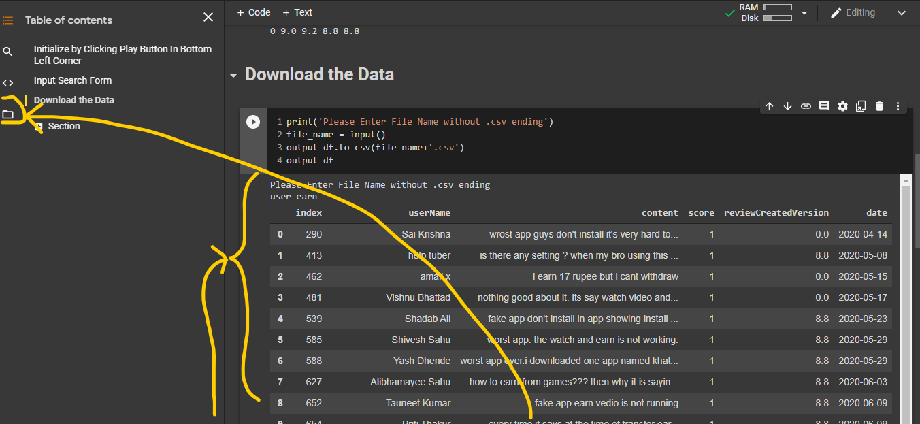

Figure 20: File Overview and Folder Section Button

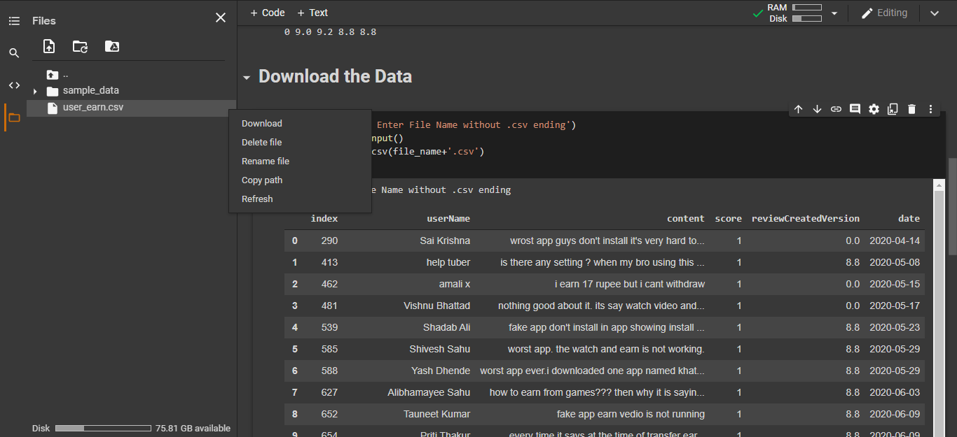

Figure 21: This is how file can be downloaded from Colab Notebook.

## **An Overview of “how to use these tools”**

The Dashboard is the main tool in the duo of these tools. The idea is to first get an overview of user sentiment from **Overall Sentiment Chart** and then get the most user terms with respect to user sentiment from **Token/Word Chart** with respect to time, rating and app version.

Then to get more detailed info of user review Back Validation tool can be used to see exact sorted user reviews. Therefore, it can be said that Back Validation tool is made to work in conjunction with User Review Dashboard.

These tools can be used as standalone piece of software if required.

**\*\*\*The End\*\*\***